**URGENT REQUEST FORM**

**Supplier’s Manual**

1. Right Click .html file and open with Internet Explorer or Google Chrome or Firefox

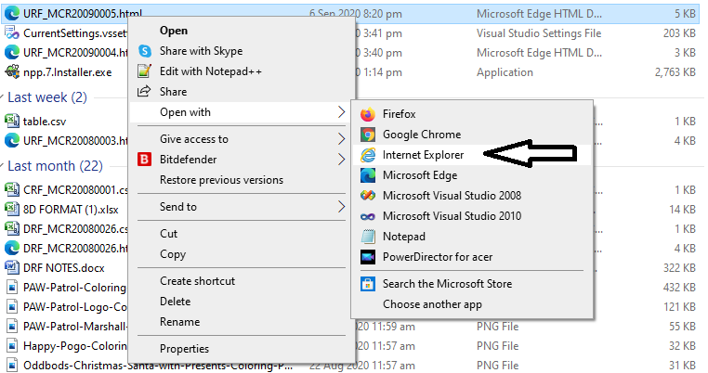

1. The .html is file look like below image (This example is open in Internet Explorer) If you see pop-up blocker “**Allow blockedcontent**” just click it or allow it. This is usually appear in IE but not in other browser like Chrome.

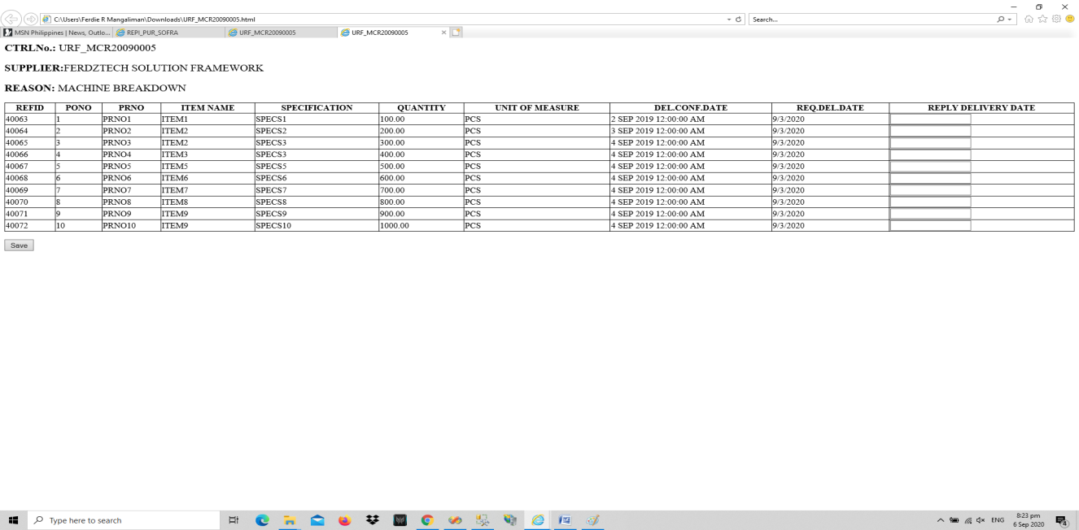

1. In REPLY DELIVERY DATE, enter **YOUR RESPONSE** then CLICK **SAVE.** If you encounter error like “**InvalidStateError**” then you should open the .html file in **Google Chrome** because IE has issue on updating BLOG file. See image below for your refference.

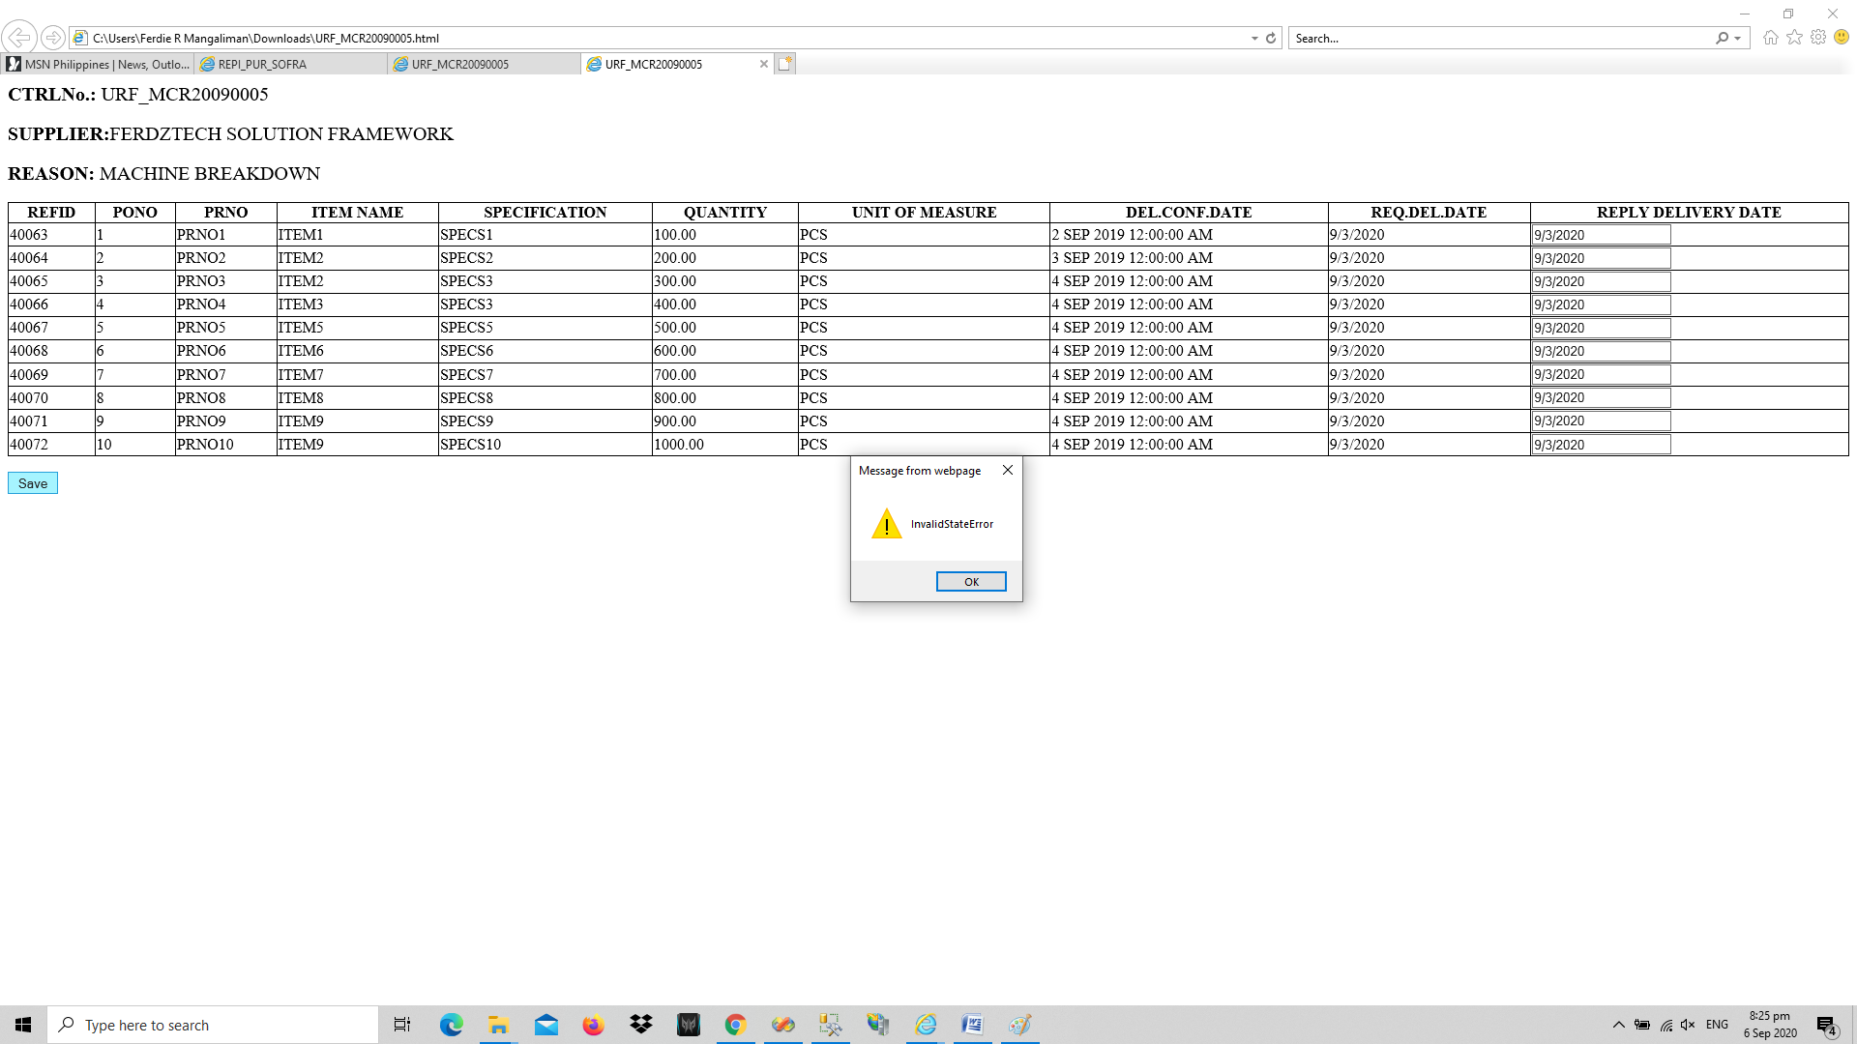

1. After entering you **reply delivery date** then the **.csv file** will automatically created. See image below (Using Google Chrome)

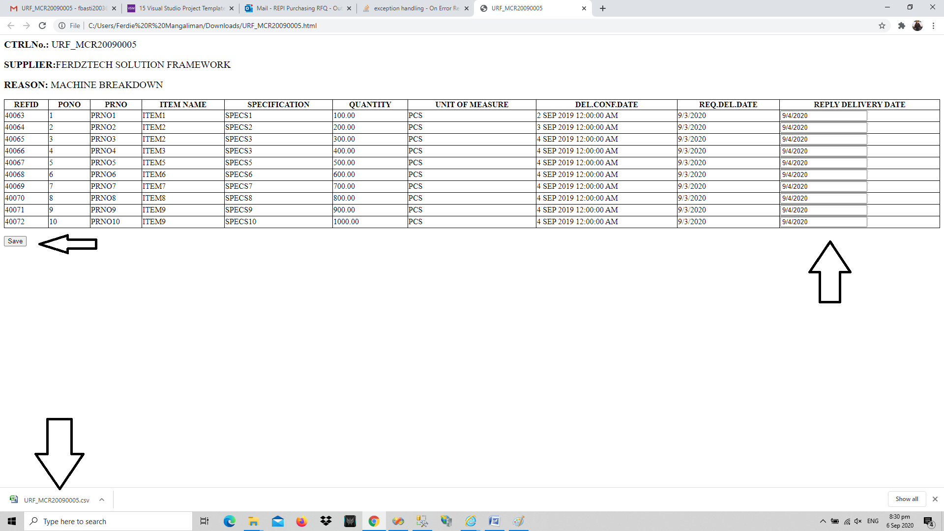

After clicking Save, you will be able to see “The URF_File.csv download has completed. If you want to see the created CSV File just click the Open Folder and should find it. The file usually save in the Download folder by default.

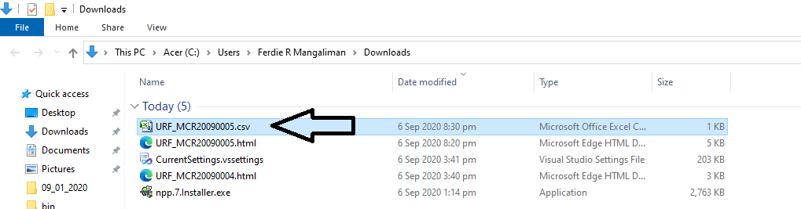

1. After that you can now attached that csv file to the original URF Email Request that you received. Do not add any message because buyer will not able to read your message because the system will only get whatever you put in the REPLY DELIVERY DATE which is in the attached CSV File. **PLEASE MAKE SURE THAT YOU ATTACHED THE CORRECT & VALID CSV FILE (URF_MCR20090005.csv (1) is NOT VALID, URF_MCR20090005.csv is VALID)**

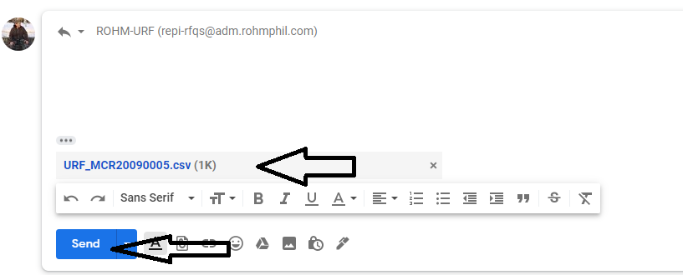

Lastly, click **SEND**

**THANK YOU!**